Is software testing gradually dying?
No. What's happening is that Quality Assurance is being merged into software development.
The old model was: the “seasoned" software developers wrote code, and then the QA team did manual tests on it to try to find bugs and whatnot. If a bug was found, they would send it back to the developers, and it could ping-pong back and forth like that for months on end.
Nowadays, the newer philosophy is that the code simply isn't deemed complete until it includes automated tests. If you work at Google, say, you write the unit tests with the code, and they're always reviewed together, period. The tests not only test the code, they also (when written well) serve as a specification of what the code is supposed to do. You can read the test assertions as saying “here's what the code should do when it runs under these given conditions.” (In fact, it's what the code must do, or else the test fails.) A common criticism during code review is that the test assertions are not in fact detailed enough, which would mean that the test could pass even when the code isn't doing what it's supposed to. (And/or doing something it's not supposed to!)
What's gradually dying is not testing, but the idea that QA can meaningfully be separated from development. In reality, testing is expanding and maturing and becoming more nuanced, not dying. Most software companies these days try to respect a model known as the testing pyramid:
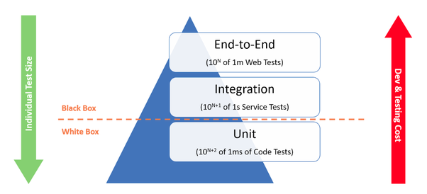
The idea is to have a large number of fast-running unit tests with narrow scope, but also to have some end-to-end testing as well, also known as QA. Integration tests are somewhere in between. To rely primarily on QA while dismissing unit tests as a waste of time (i.e. the “old way") is to flip the pyramid upside down.

